**Q1:**

Reflecting on my journey with oTree, a linchpin in the realms of experimental economics and behavioral game theory, I've stumbled upon some real challenges, mainly rooted in its awkward dance with Windows systems. My ambition to craft flexible models for various economic and social quandaries, inspired in part by thoughts of exploring cybersecurity through economic viewpoints as hinted by Chen (2020), often felt thwarted by this mismatch. The dream of seamlessly deploying models to test economic theories or simulate cybersecurity situations was constantly tripped up by the software's stubborn incompatibility and the seemingly Sisyphean task of tracking down the oTree file path on my machine. These hurdles did more than just slow me down; they put up walls around my ability to conduct research efficiently.

This friction with Windows systems is particularly disheartening given its ubiquity in academic and professional circles. Such incompatibility narrows the gateway to oTree's capabilities, dimming the lights on the diverse and profound research potential in experimental economics. The added struggle of locating the necessary file paths only pours salt on these operational wounds, introducing delays and frustrations that feel antithetical to the spirit of research.

The need for a solution is clear, one that not only smooths over these operational bumps but also pushes the envelope in experimental economics methodologies, especially around strategic interactions. A software that outpaces oTree would ideally triumph in compatibility across operating systems, ease of installation and setup, and user interface intuitiveness.

First off, bridging the software across various operating systems, including Windows, would crack open the door wider for researchers, enriching the field with more inclusive and applicable insights. This is crucial for integrating the software into the diverse tech landscapes of academic and research settings globally.

Second, streamlining the setup process could transform the user experience. Imagine a tool that cuts through the setup clutter, offering a clear path forward, freeing researchers to dive deeper into the essence of their experiments rather than untangling installation snags.

Lastly, a user interface that intuitively shepherds users through experiment design and deployment could democratize experimental economics research further. Lowering the software's learning curve could unleash its full potential, sparking more innovative and impactful research.

These enhancements aren't just about technical fixes; they're about opening up new horizons for experimental economics to deepen our grasp of complex economic behaviors and systems. By addressing the current limitations with oTree, particularly around software compatibility and ease of use, we could foster a more streamlined and inclusive research process. This isn't only good news for academics; it has wider ramifications for policy-making and economic strategies, potentially leading to more enlightened and effective decisions.

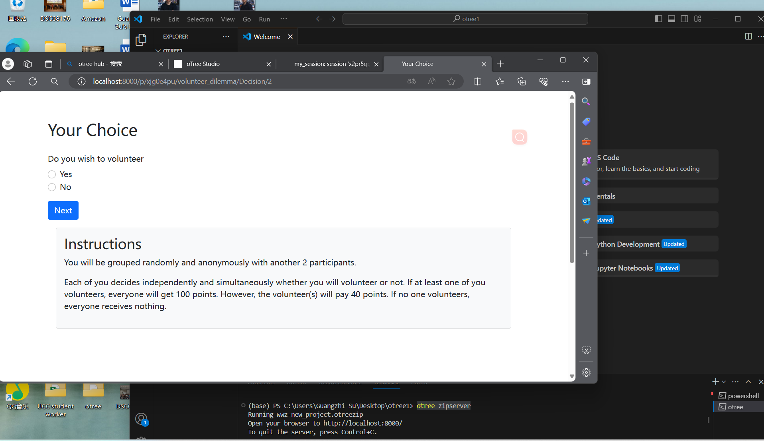

Chen, Daniel L., Martin Schonger, and Chris Wickens. "oTree—An open-source platform for laboratory, online, and field experiments." Journal of Behavioral and Experimental Finance 9 (2015): 88-97. <https://www.sciencedirect.com/science/article/pii/S221463501830162X>.

In the analysis, you must provide at least one example of your personal experience in deploying the trust game using oTree, together with a screenshot.

**Q2:**

Delve into the limitations of current multi-agent reinforcement learning (MARL) frameworks, focusing on environment constraints and agent algorithm customizations. Choose a classic game (e.g., Prisoner's Dilemma, Battle of the Sexes, or the Trust Game) to illustrate these limitations. Describe the development process of a MARL agent for your selected game, detailing the definition of states, actions, and rewards grounded in fundamental behavioral assumptions. Your analysis should provide insights into overcoming MARL's current limitations, fostering advancements in the field. Submit a comprehensive report (500 words max) with your findings and proposals.

In the analysis, you must provide at least one example of your personal experience in endeavoring to deploy the gameplay using one of the MARL frameworks, together with a screenshot.

Diving into the world of multi-agent reinforcement learning (MARL), especially through classic strategic games like the Trust Game, is like opening a Pandora's box of both dazzling possibilities and glaring shortcomings. These MARL frameworks, designed to mimic the intricate dance of decision-making among autonomous entities, shine a light on the vast potential for dissecting the intricacies of strategy. Yet, when you get down to brass tacks, applying MARL in real-world scenarios—based on my own tinkering—hits a wall of challenges. These range from the rigid confines of the environments we can simulate to the tightrope walk of customizing algorithms, not to mention the sheer volume of trial and error needed to craft effective strategies.

Take the Trust Game, for instance. It's all about the delicate balance of cooperation and trust. To model such a game in MARL, you've got to get into the weeds with defining states, actions, and rewards that reflect the complexities of human behavior. States might cover a range of factors, from what each player's got in their hand to their past moves and how trustworthy they seem. Actions could involve deciding how much money to pass along, while rewards are tied up in the immediate payoff and the longer game of relationship building. But here's the rub: capturing these nuanced decisions and the subtleties of trust in a model demands a level of sophistication that often feels just out of reach with our current MARL toolset.

My own stab at modeling the Trust Game using MARL was a real eye-opener to these limitations. Despite the promise of these frameworks to autonomously evolve gameplay logic, progress was painfully slow. This sluggish pace is symptomatic of a broader issue in MARL—needing a mountain of trials before the agents start to get the hang of forming nuanced, effective strategies. In the Trust Game scenario, this meant an arduously long road to modeling trust and reciprocity that really threw a wrench in the works of my research.

This whole journey underscores a pressing need for leaps forward in MARL tech to overcome these barriers. Tackling the snags of environmental rigidity and algorithm customization is one thing. But just as critical is revving up the learning engines within these frameworks. Imagine agents picking up the pace, learning from each interaction with a fraction of the trials currently required. That could seriously shake up the feasibility of using MARL for the complex chess game of strategic simulations.

We could see breakthroughs like pre-trained models that come with a baseline grasp of strategic dos and don'ts, slashing the number of trial runs needed. Or perhaps weaving in machine learning techniques that better mimic human thought patterns and decisions, lending a new layer of realism and relevance to MARL simulations.

Pushing past these current confines and turbocharging the adaptability and efficiency of MARL frameworks isn't just tinkering around the edges—it's about unlocking a whole new realm of potential. These enhancements could revolutionize how accurately we simulate strategic interactions, like the Trust Game, and widen the scope for MARL's application in deciphering the complexities of various systems and scenarios. Advancing MARL's capabilities is not just a win for artificial intelligence; it's a leap forward in our quest to understand the deep mechanics of strategic decision-making and navigating complex, dynamic systems.

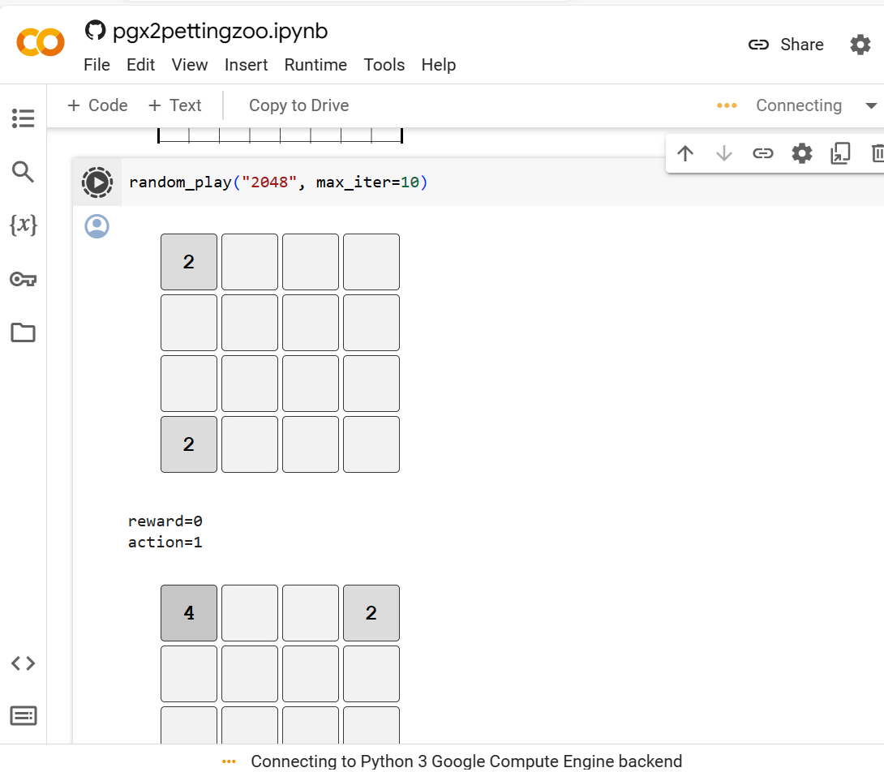

Q3:

Building upon the insights provided by Professor Bing Luo's paper on "Cost-Effective Federated Learning in Mobile Edge Networks," there is a noteworthy attempt to delineate an optimized incentive structure that motivates client participation in federated learning, alongside managing economic constraints effectively. The core of this research revolves around enhancing the efficiency and participation rates in federated learning models, especially within mobile edge networks, which is a crucial area considering the growing edge computing demands and data privacy concerns in today’s digital era.

The paper's primary research question seeks to unravel how federated learning models can be designed to be both cost-effective and appealing enough to encourage broad participation. This is a significant challenge, given that federated learning involves training machine learning models across numerous devices or servers, with data localization at its core, thus mitigating central data storage and processing challenges but introducing complexities in synchronization, data diversity, and model updating.

The methodologies employed in the study leverage a combination of algorithmic designs and economic models to simulate and analyze the interaction between cost constraints and participation incentives. This interdisciplinary approach allows for a nuanced understanding of the underlying dynamics that govern federated learning networks, highlighting the balance between operational costs and the benefits derived from increased client involvement.

Application scenarios discussed in the paper include mobile edge computing environments where federated learning can significantly enhance privacy and efficiency. These scenarios are particularly relevant given the proliferation of smart devices and the consequent surge in data generation at the edge of the network. By applying federated learning, the paper proposes a framework that not only addresses the economic feasibility of such models but also aligns with the privacy-preserving needs of the modern digital landscape.

Critically examining the research questions posed by the paper, it becomes evident that while maximizing client participation under economic constraints is crucial, the quality of participation and the diversity of the data collected are equally important. The presumption that increased client involvement inherently leads to a more representative dataset might overlook the potential for data skewness or overrepresentation of certain data types, as mentioned in the initial answer. This raises a more nuanced question: How can federated learning models ensure both quantitative and qualitative data representation? Exploring alternative incentives that prioritize data diversity and model robustness could offer more value, enriching the federated learning ecosystem with a broader range of insights and applications.

The methodology, while comprehensive, could benefit from a deeper examination of the assumptions regarding participant behavior and data distribution. For instance, the assumption of linearly beneficial increases in client numbers may not hold in scenarios where data becomes increasingly redundant or less diverse. Incorporating adaptive methodologies that dynamically adjust incentives based on the current state of data diversity and model accuracy could provide a more sophisticated approach to optimizing federated learning networks.

Regarding application scenarios, the rapid advancement in technologies such as blockchain, generative AI, and quantum computing presents new frontiers for federated learning. Blockchain technology, for instance, could offer an immutable ledger for model updates, enhancing trust and transparency in the federated learning process. Similarly, leveraging generative AI could aid in synthetically balancing datasets where real data is scarce or biased, thereby addressing the critique of overrepresentation.

Lastly, considering the role of bounded rationality and incorporating psychological heuristics or various AI models could significantly enrich the research. Understanding how human and AI agents make decisions within federated learning environments could unveil new strategies for designing incentives, addressing privacy concerns, and ultimately enhancing the efficiency and effectiveness of federated learning models. This holistic approach, expanding beyond the confines of computer science and economics, could pave the way for more adaptive, secure, and inclusive federated learning ecosystems.

Bibliography:

Chen, Daniel L., Martin Schonger, and Chris Wickens. "oTree—An open-source platform for laboratory, online, and field experiments." Journal of Behavioral and Experimental Finance 9 (2015): 88-97. <https://www.sciencedirect.com/science/article/pii/S221463501830162X>.

